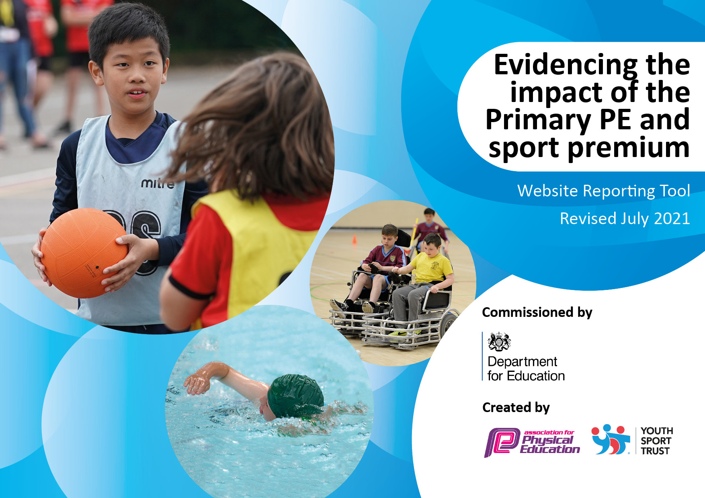

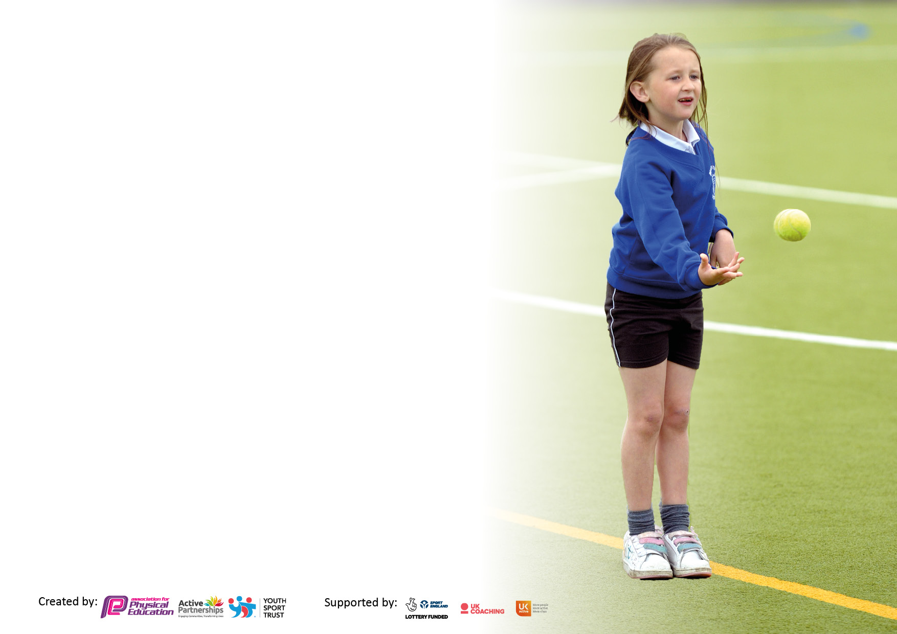

It is important that your grant is used effectively and based on school need. The Education Inspection Framework makes clear there will be a focus on **‘whether leaders and those responsible for governors all understand their respective roles and perform these in a way that enhances the effectiveness of the school’**.

Under the Quality of Education Ofsted inspectors consider:

**Intent** - Curriculum design, coverage and appropriateness

**Implementation** - Curriculum delivery, Teaching (pedagogy) and Assessment

**Impact** - Attainment and progress

To assist schools with common transferable language this template has been developed to utilise the same three headings which should make your plans easily transferable between working documents.

Schools must use the funding to make **additional and sustainable** improvements to the quality of Physical Education, School Sport and Physical Activity (PESSPA) they offer. This means that you should use the Primary PE and sport premium to:

* Develop or add to the PESSPA activities that your school already offer
* Build capacity and capability within the school to ensure that improvements made now will benefit pupils joining the school in future years
* The Primary PE and sport premium should not be used to fund capital spend projects; the school’s budget should fund these.

Pleasevisitgov.ukfortherevisedDfEguidanceincludingthe5keyindicatorsacrosswhichschoolsshoulddemonstrate animprovement.Thisdocumentwillhelpyoutoreviewyourprovisionandtoreportyourspend.DfEencouragesschools to use this template as an effective way of meeting the reporting requirements of the Primary PE and sport premium.

We recommend you start by reflecting on the impact of current provision and reviewing the previous spend.

Schools are required to publish details of how they spend this funding, including any under-spend from 2019/2020, as well as on the impact it has on pupils’ PE and sport participation and attainment. **All funding must be spent by 31st July 2022.**

We recommend regularly updating the table and publishing it on your website throughout the year. This evidences your ongoing self-evaluation of how you are using the funding to secure maximum, sustainable impact. Final copy must be posted on your website by the end of the academic year and no later than the 31st July 2021. To see an example of how to complete the table please click HERE.

Created by: Supported by:

**Details with regard to funding**

Please complete the table below.

|  |  |
| --- | --- |
| Total amount carried over from 2019/20 | £24,000 |
| Total amount allocated for 2020/21 | £17,350 |
| How much (if any) do you intend to carry over from this total fund into 2021/22 | £19,052 |
| Total amount allocated for 2021/22 | £17,270 |
| Total amount of funding for 2021/22. To be spent and reported on by 31st July 2022. | £36,355 |
| Underspent – to be carried forward to 22/23 | £10237 |

**Swimming Data**

Please report on your Swimming Data below.

|  |  |
| --- | --- |
| Meeting national curriculum requirements for swimming and water safety.  N.B. Complete this section to your best ability. For example you might have practised safe self-rescue techniques on dry land which you can then transfer to the pool when school swimming restarts.  **Due to exceptional circumstances priority should be given to ensuring that pupils can perform safe self rescue even if they do not fully meet the first two requirements of the NC programme of study** |  |
| What percentage of your current Year 6 cohort swim competently, confidently and proficiently over a distance of at least 25 metres?  **N.B.** Even though your pupils may swim in another year please report on their attainment on leaving primary school at the end of the summer term 2021.  Please see note above | 35% |
| What percentage of your current Year 6 cohort use a range of strokes effectively [for example, front crawl, backstroke and breaststroke]?  Please see note above | 23% |
| **What percentage of your current Year 6 cohort perform safe self-rescue in different water-based situations?** | 8% |
| Schools can choose to use the Primary PE and sport premium to provide additional provision for swimming but this must be for activity **over and above** the national curriculum requirements. Have you used it in this way? | No |

**Action Plan and Budget Tracking**

Capture your intended annual spend against the 5 key indicators. Clarify the success criteria and evidence of impact that you intend to measure to evaluate for pupils today and for the future.

|  |  |  |  |  |
| --- | --- | --- | --- | --- |
| **Academic Year:** 2020/21 | **Total fund allocated:** | **Date Updated:** | |  |
| **Key indicator 1:** The engagement of all pupils in regular physical activity – Chief Medical Officers guidelines recommend that primary school pupils undertake at least 30 minutes of physical activity a day in school | | | | Percentage of total allocation: |
| Total over all 5 indicators = 77.15% |
| **Intent** | **Implementation** | | **Impact** |  |
| Your school focus should be clear what you want the pupils to know and be able to do and about  what they need to learn and to  consolidate through practice: | Make sure your actions to achieve are linked to your intentions: | Funding allocated: | Evidence of impact: what do pupils now know and what can they now do? What has changed?: | Sustainability and suggested next steps: |
| 1. All pupils to take part in at least 30 minutes of structured physical activity every school day. 2. All children to access 2 x 1-hour high quality PE lessons a week. 3. Most children to participate in increased physical activity through school and community clubs, including competition. 4. More opportunities provided for active learning in all lessons to ensure that children are more active. 5. Sports Leaders to be positive role models for sport. 6. Playtimes to include structured physical activity. | Movement breaks to be used throughout the day (Go Noodle, I Moves, Active 15) at least 15 minutes daily.  Structured physical activity timetabled for Break and lunch times. (Each class at least 3 times a week).  Structured Physical activity available during breakfast and after school clubs.  Sports Engagement Manager to track all pupils’ daily activity through YST heatmap.  EYFS – continual access to outdoor area and structured physical development activities  KS1 – opportunity for physical activity maximized by having their own gated outdoor areas which included equipment such as adapted bikes.  Clearly timetabled sessions for each class, including use of school hall to ensure weather does not disrupt provision.  Each week each class has an indoor and outdoor lesson to ensure broad coverage of skills.  Ensure we have resources required for wide variety of PE lessons.  Staff aware of long term and medium term plans for PE.  Annual subscription to PE Hub. Which includes full lesson plan as well as skills videos as well as progression and assessment documents  Rounders pitches and athletics track markings  Staff involve pupils in city wide dance festivals to showcase learning in PE.  PE Hub and Sports engagement manager/ PE lead to support staff with planning and resourcing their lessons.  Sports Engagement Manager to track whole school participation in school sports clubs and community sports clubs. This data to be used to provide targeted provision.  Wraparound breakfast and after school clubs provides opportunity for structured physical activity.  Sport extra-curricular clubs available 4 night a week: To include, football (Girls and boys), martial arts and tennis.  Use pupil voice to ensure most popular clubs are prioritised.  Commonwealth Games Family Sports Day. Local community sports clubs invited in to deliver sessions, signposting children and families to community sports clubs  Inclusive tennis initiative run by LTA  At school for pupils to access free of charge.  Sports Engagement officer to have direct conversations with parents of talented athletes and support them in successfully progressing in the sports community pathway.  Annual subscription to School Games and SEND Active Games to provide festival and competitive opportunities for all.  School to host School games and SEND active competitions on school site to maximise participation of our pupils.  Staff encouraged to use exercise as a way to boost mental health and wellbeing -movement breaks, PSHE warm up games - Share good practices including Go Noodle, Just Dance, Jo Wicks, circle games etc.  Attended and hosted ERASMUS ACTIVE project. An international initiative to share active learning ideas across the curriculum. Staff who attend to feedback and trial new ideas.  Subject leaders to plan in opportunities for active learning, within the whole curriculum. E.g Archery as part of Raiders and Invaders Topic- Vikings.  Active maths lessons to be accessed by all pupils at least once a half term. Monitored by maths Lead.  Outdoor learning opportunities are maximised across the curriculum for all children.  Money to be carried over to facilitate a forest school environment and staff training.  Opportunities for learning outside of school grounds, incorporated physical activity, e.g. local area walks, walking children to local school for sporting matches or other collaborative learning opportunities.  Sports leaders to lead break time and lunchtime activities.  Sports leaders to assist in organisation and delivery of intra and inter school competitions.  Outdoor gym equipment purchased and installed.  Outdoor table tennis tables purchased.  Clear playtime and lunchtime rota for classes to participate in all physical activities.  Sports leaders lead structured physical activity. | Sports Engagement officer  £5,750 | Children understand the mental health benefits of exercise.  Children participate in a range of accessible well-being activities which can be easily accessed in and out of school.  Children have been introduced to new sports – table tennis and shown how they can adapt for the home, dining table and temporary net., use hands as bat, adaptable and inclusive.  A progressive, strategic curriculum allows children to build skills and knowledge year on year.  Children experience a wide range of sporting opportunities are provided from gymnastics and yoga to badminton and handball, Boccia and Kurling.  Children have access to a wide range of sporting equipment eg Boccia, Kurling,  Archery.  All lessons are inclusive due to the wide range of sporting equipment available – raising participation and achievement for all children.  Children are taught via well planned lessons, formulated by external experts and are adapted by staff using the STEP principle to ensure all learners can access and are challenged.  Children get opportunity to engage in structured physical activity with pupil across school.  External providers are used to provide specialist provision, providing more able athletes with challenge and opportunity for inter school competition.  Children have had opportunity to perform in front of city wide audiences, raising self-confidence, self-efficacy and achievement.  Pupils have progressed through sport community pathways. Including local clubs and higher-level clubs such as being scouted for Aston Villa Football Club. | Continue  Look into using any carried over funding plus some of next year’s allocation to purchase all weather daily mile track.  Still to purchase:   * Sunken, removable netball posts * Basketball posts and new balls   Lunchtime and break time provision be continued and extra structured opportunities to be included e.g. basketball.  Pupil voice to be used to organise after school clubs for September 2022.  Large school field space to be used more:  Daily mile track  Forest school  To sustain and create new successful links with local sports clubs.  To use RFU community days to access Ruby coaching at least once a Year. Providing specialist rugby coaching for all pupils.  To hold an annual community sports day for whole school community.  To source alternative extracurricular provision e.g. gymnastics, boxercise.  Collaborate further with LTA to provide further opportunities for specialist tennis coaching  Sports engagement manager role to be continued and adapted to continue to progress standards in PE across school. |
| **Key indicator 2:** The profile of PESSPA being raised across the school as a tool for whole school improvement | | | | Percentage of total allocation: |
| Total over all 5 indicators = 77.15% |
| **Intent** | **Implementation** | | **Impact** | £810 |
| Your school focus should be clear what you want the pupils to know and be able to do and about  what they need to learn and to  consolidate through practice: | Make sure your actions to achieve are linked to your intentions: | Funding allocated: | Evidence of impact: what do pupils now know and what can they now do? What has changed?: | Sustainability and suggested next steps: |
| 1. To engage whole school community in understanding importance of being active and participating in sport. 2. Use PE and sport to actively promote the schools core values. 3. To use PE and sport to encourage children “to be the be the can be.” 4. To promote cultural capital and ensure children are equipped to live in the local community. 5. PE curriculum is used to promote heathy lifestyles. 6. The curriculum and enrichment offer, instills a love for PE and Sport, which encourages pupils to engage in sustained activity for life. 7. PE curriculum and enrichment offer develop life skills and improve growth mindset. 8. Children develop fine and gross motor skills. 9. Physical activity is used to motivate and engage pupils in other curriculum areas. 10. Raised awareness in school of sporting opportunities in the local community 11. Raise the profile of sporting competition in school by providing intra-school competitions 12. Sport and PE is celebrated in School and across the wider school community. 13. Continue to champion Inclusive sport in the local community and across local schools. | Whole school events including CWG sport day and annual sports day, and families are encouraged to join in physical activities with their children.  Home fitness challenges sent home throughout the year eg skipping challenge.  SEND Active home challenges using adaptive resources such as frying ban and socks bat and ball activities to be sent home throughout the year.  Homework activities to encourage engagement in physical activities eg Commonwealth Games Topic homework included visiting the local swimming baths or climbing wall.  Sports noticeboards in school with details of fixtures and photos of events.  Sporting events and community sporting events clearly displayed in external notice board.  Half termly newsletters to school community about sports events.  Swimming lessons moved to Alan Higgs as it is more local facility.  Free Swimming lessons for HAF children accessed during school holidays for pupils.  Organise termly well-being activities in the local community for each class e.g. Foot Golf at War Memorial Park.  Curriculum action plans are linked to whole school values.  Sports Leaders given opportunity to support in the leadership, planning, and delivery of intra-school and inter-school events hosted at school.  School Games and SEND ACTIVE values mirror/ compliment schools values.  Children are encouraged to look smart for PE, wear the correct kit.  Children discuss sportsmanship, stewardship and understand that at external competitions they are ambassadors for school.  Children learn how to engage in physical activity which interests and inspires them.  They are aware of opportunities available in the community and experience visiting local facilities.  Sports Engagement Manager to organize and track participation in intra and inter school competitions.  Children to attend Queens Baton relay as part of curriculum and 3 children to attend as a enrichment opportunity at The Wave with family member.  Participation in initiatives such as Go Parks.  Enrichment offer to attend Wimbledon.  Sports leaders create posters and write blogs/ social media posts for events.  Physical Literacy is an integral part of EYFS curriculum, - LTP  CWG day  Local club links established with Netball club, tennis club, Rugby club– posters displayed.  Intra school competitions held each half term by Sports Engagement process.  Sport achievement celebration assemblies  intra-school competitions are celebrated using House Point system.  Sporting achievements are included in the newsletter.  Sport , PE and enrichment offer are celebrated on social media.  Participate in city ROH inclusive dance project.  Annual subscription to SEND Active  LTA inclusive tennis hub host school. | CWG sports day  £310  Wimbledon £500 | The raised profile of PE and enrichment offer has ensured children receive a holistic education and is contributing to creating well rounded learns, improving:   * Critical thinking skill -OAA (problem solving) units included in LTP * Physical skills – Fine and gross motor skills are developed through the wide range of opportunities available and plethora of resources available. * Social skill, - children learn to work as a team, support each other, coach each other, children build friendships with other children through collaborative projects with other schools such as inclusive tennis scheme. * Personal skills – children learn to take are of equipment, how to store it correctly, how to get changed and dress themselves.   Leadership opportunities such as Sports Leaders offer opportunity to take on responsibilities and be involved in the organisation of events. | Already enrolled in next year’s ROH dance program – The Nutcracker which provides CPD for teachers, opportunity for children to showcase their learning and enrichment offer, taking 20 children to The Royal Ballet in December.  Develop forest school provision into curriculum  Apply for Wimbledon 2023 tickets  Use contacts to apply for opportunities to visit local sporting events such as CCFC Wasps rugby and netball  Extend club links into other sports – gymnastics.  Explore use of school hall for community sport/physical activity – Zumba club etc |

|  |  |  |  |  |
| --- | --- | --- | --- | --- |
| **Key indicator 3:** Increased confidence, knowledge and skills of all staff in teaching PE and sport | | | | Percentage of total allocation: |
| Total over all 5 indicators = 77.15% |
| **Intent** | **Implementation** | | **Impact** | £5200 |
| Your school focus should be clear | Make sure your actions to | Funding | Evidence of impact: what do | Sustainability and suggested |
| what you want the pupils to know | achieve are linked to your | allocated: | pupils now know and what | next steps: |
| and be able to do and about | intentions: |  | can they now do? What has |  |
| what they need to learn and to |  |  | changed?: |  |
| consolidate through practice: |  |  |  |  |
| 1. Raise the quality of PE teaching throughout the school and ensure skills progression. 2. Staff are confident teaching all abilities including those with specific sporting talents and children with additional needs 3. Appropriate staff CPD is accessed and shared with whole school.   PE lead to work in partnership with local schools. | Annual subscription to PE Hub.  Teachers to use video links to improve delivery of skills.  Teachers to actively use skills progression tracker for their year group.  Use of technology and online learning to develop staff confidence.  Use of Sport Engagement Manager for coaching staff and advice.  Use of SGO to inform and develop PE team.  School Games and SEND active competitions embedded in curriculum LTP  PE team, SGO and Send Active team to provide support to ensure an inclusive curriculum.  STEP principal to be applied by all staff to differentiate lessons.  Dance CPD refresher for PE lead.  God professional working relationships established with local schools which has increased opportunity for inter school competition. | PE Hub Subscription  £450  Sport engagement officer teaching PE  £4,750 | Children have had opportunity to play competitive sports against local schools  Children have accessed School games competitions and SEND Active competitions, creating good links with local SEN schools.  We have competed to a better standard in School games and SEND Active competitions | PE lesson observations to be undertaken by PE leader.  Staff skills audit to be completed  CPD for Sports engagement officer in sports less confident in teaching.  To establish a preparation routine for competitions, including extra curricular clubs to continue to compete at a high standard.  To reach city finals in at least one School Games event.  CPD surrounding physical literacy, especially with regards to teaching foundation skills in EYFS and lower school.  Extend extracurricular offer, using specialists.  Ensure all stff teach at least one hour of PE a week to maintain skills and confidence.  FOCUS AREA FOR 2022-23 |
| **Key indicator 4:** Broader experience of a range of sports and activities offered to all pupils | | | | Percentage of total allocation: |
| Total over all 5 indicators = 77.15% |
| **Intent** | **Implementation** | | **Impact** |  |
| Your school focus should be clear | Make sure your actions to | Funding | Evidence of impact: what do | Sustainability and suggested |
| what you want the pupils to know | achieve are linked to your | allocated: | pupils now know and what | next steps: |
| and be able to do and about | intentions: |  | can they now do? What has |  |
| what they need to learn and to |  |  | changed?: |  |
| consolidate through practice: |  |  |  |  |
| Additional achievements:   1. PE Curriculum is broad and varied and insights curiosity and excellence. 2. Improve mental health and wellbeing 3. Children to have opportunities to participate in sport in the community. 4. Equipment to support introduction of new sports 5. Increase % of children able to swim 25m. 6. Provide opportunities for inclusive sport | LTP is broad and varied, competition elements are embedded.  PE Hub  Competition is included but does not dictate  Enrichment offer – Wimbledon,  Wellbeing trips for classes e.g.: organising trips to local sporting venues e.g. Foot golf at War Memorial Park.  More effective use of wider environment – leisure centres.  Introduce children to activities which are sustainable at home e.g. Joe Wicks/Go Noodle  Investigate organising trips to sporting venues in the local community. Eg Foot Golf at the War Memorial Park, to encourage families to access in their spare time  Swimming lessons at Alan Higgs as it is a more local venue.  Performing in dance programs at Coventry cathedral.  Children accessed free swimming opportunities out of school.  Participation in Go Parks  Adapted bikes  Table Tennis Tables  Outdoor gym  Netball nets  Basketball nets  Tennis equipment  Provide Swimming lessons to more pupils in KS2.  Dance program  SEND Active subscription  Sports Engagement Manager to identify G&T children and signpost them to attend clubs. | Outdoor gym  £13,500 | Children experience sports from all genres: strike and field, invasion games, net games, target games, dance, gymnastics, swimming.  Children experience individual and team games.  Children experience activities beyond the National Curriculum including calming strategies / wellbeing/ critical thinking activities such as– Yoga, skipping, creative problem solving activities  Children are taught National Governing body modified games such as Netball High 5.  Children have opportunity to develop physical literacy and fundamental movement skills.  Opportunity to coach each other are included in planning  Opportunity to reflect and evaluate on performance. This includes using ICT e.g. recording themselves performing and then evaluating themselves.  Learners have increased confidence, resilience, perseverance, adaptability, ability to reflect, self confidence. These skills transfer across the curriculum.    Offered booster swimming to children in Year6 who were almost swimming 25m in year 5.  Children and families are more active in the home:   * Explored the local environment visiting local parks for Go Parks. School came Second place in Go Parks 2– awarded trophy. * Children and families participate in PE challenges – skipping. * Increased numbers of children have joined external clubs. E.g. children joined local gymnastics club after really enjoying PE lessons.   Wider range of equipment available for structured PE at break and lunchtimes.  Engages children, broadens experiences, increases curiosity, improves gross and fine motor skills, physical literacy  Inclusion – opportunities for all to participate. | Forest school  Daily Mile track  2022-23 increase Swimming offer to 2 terms so that all children go swimming for 2 terms across 2 years.  Each class to have a PE out of school wellbeing experience.  Equipment audit to be completed.  2022-23 dance program to be attended.  Increase extracurricular offer.  Monitoring of delivery of LTP across school. |

|  |  |  |  |  |
| --- | --- | --- | --- | --- |
| **Key indicator 5:** Increased participation in competitive sport | | | | Percentage of total allocation: |
| Total over all 5 indicators = 77.15% |
| **Intent** | **Implementation** | | **Impact** | £857.82 |
| Your school focus should be clear | Make sure your actions to | Funding | Evidence of impact: what do | Sustainability and suggested |
| what you want the pupils to know | achieve are linked to your | allocated: | pupils now know and what | next steps: |
| and be able to do and about | intentions: |  | can they now do? What has |  |
| what they need to learn and to |  |  | changed?: |  |
| consolidate through practice: |  |  |  |  |
| 1. Participate in School Games competitions 2. Participate in SEND Active activities 3. Inclusive sport opportunities   Increase Intra-school competitions. | School Games annual subscription.  Participation to be monitored by Sports Engagement Manager.  Hosted School Games competitions – rounders  Competitions are prepared for in advance through curriculum lessons and or through after school clubs.  SEND Active annual subscription  Participation to be monitored by Sports Engagement Manager.  Hosted SEND Active competitions – x country  Sports leaders hosted event.  Inter school inclusive sports festivals held at Howes  Hosted inclusive tennis lessons for local community schools.  Termly intra-class, inter-class, inter house competitions.  Participation to be monitored by Sports Engagement Manager.  Sports day – inter house competition | School games subscription  £250  SEND Active games subscription  £425  Travel:  £182.82 | The range of competitive and festival sport on offer enables all children to participate so that they grow in confidence, motivation and competence.  Children are taught core values such as team work, resilience, courage, perseverance.  Children hold posts of responsibility, developing life skills. | To have a curriculum and after school offer to prepare for competitions. |

|  |  |
| --- | --- |
| Signed off by | |
| Head Teacher: | Zoe Pollard |
| Date: | 25/07/22 |
| Subject Leader: | M. Walters |
| Date: | 14.7.22 |
| Governor: |  |
| Date: |  |