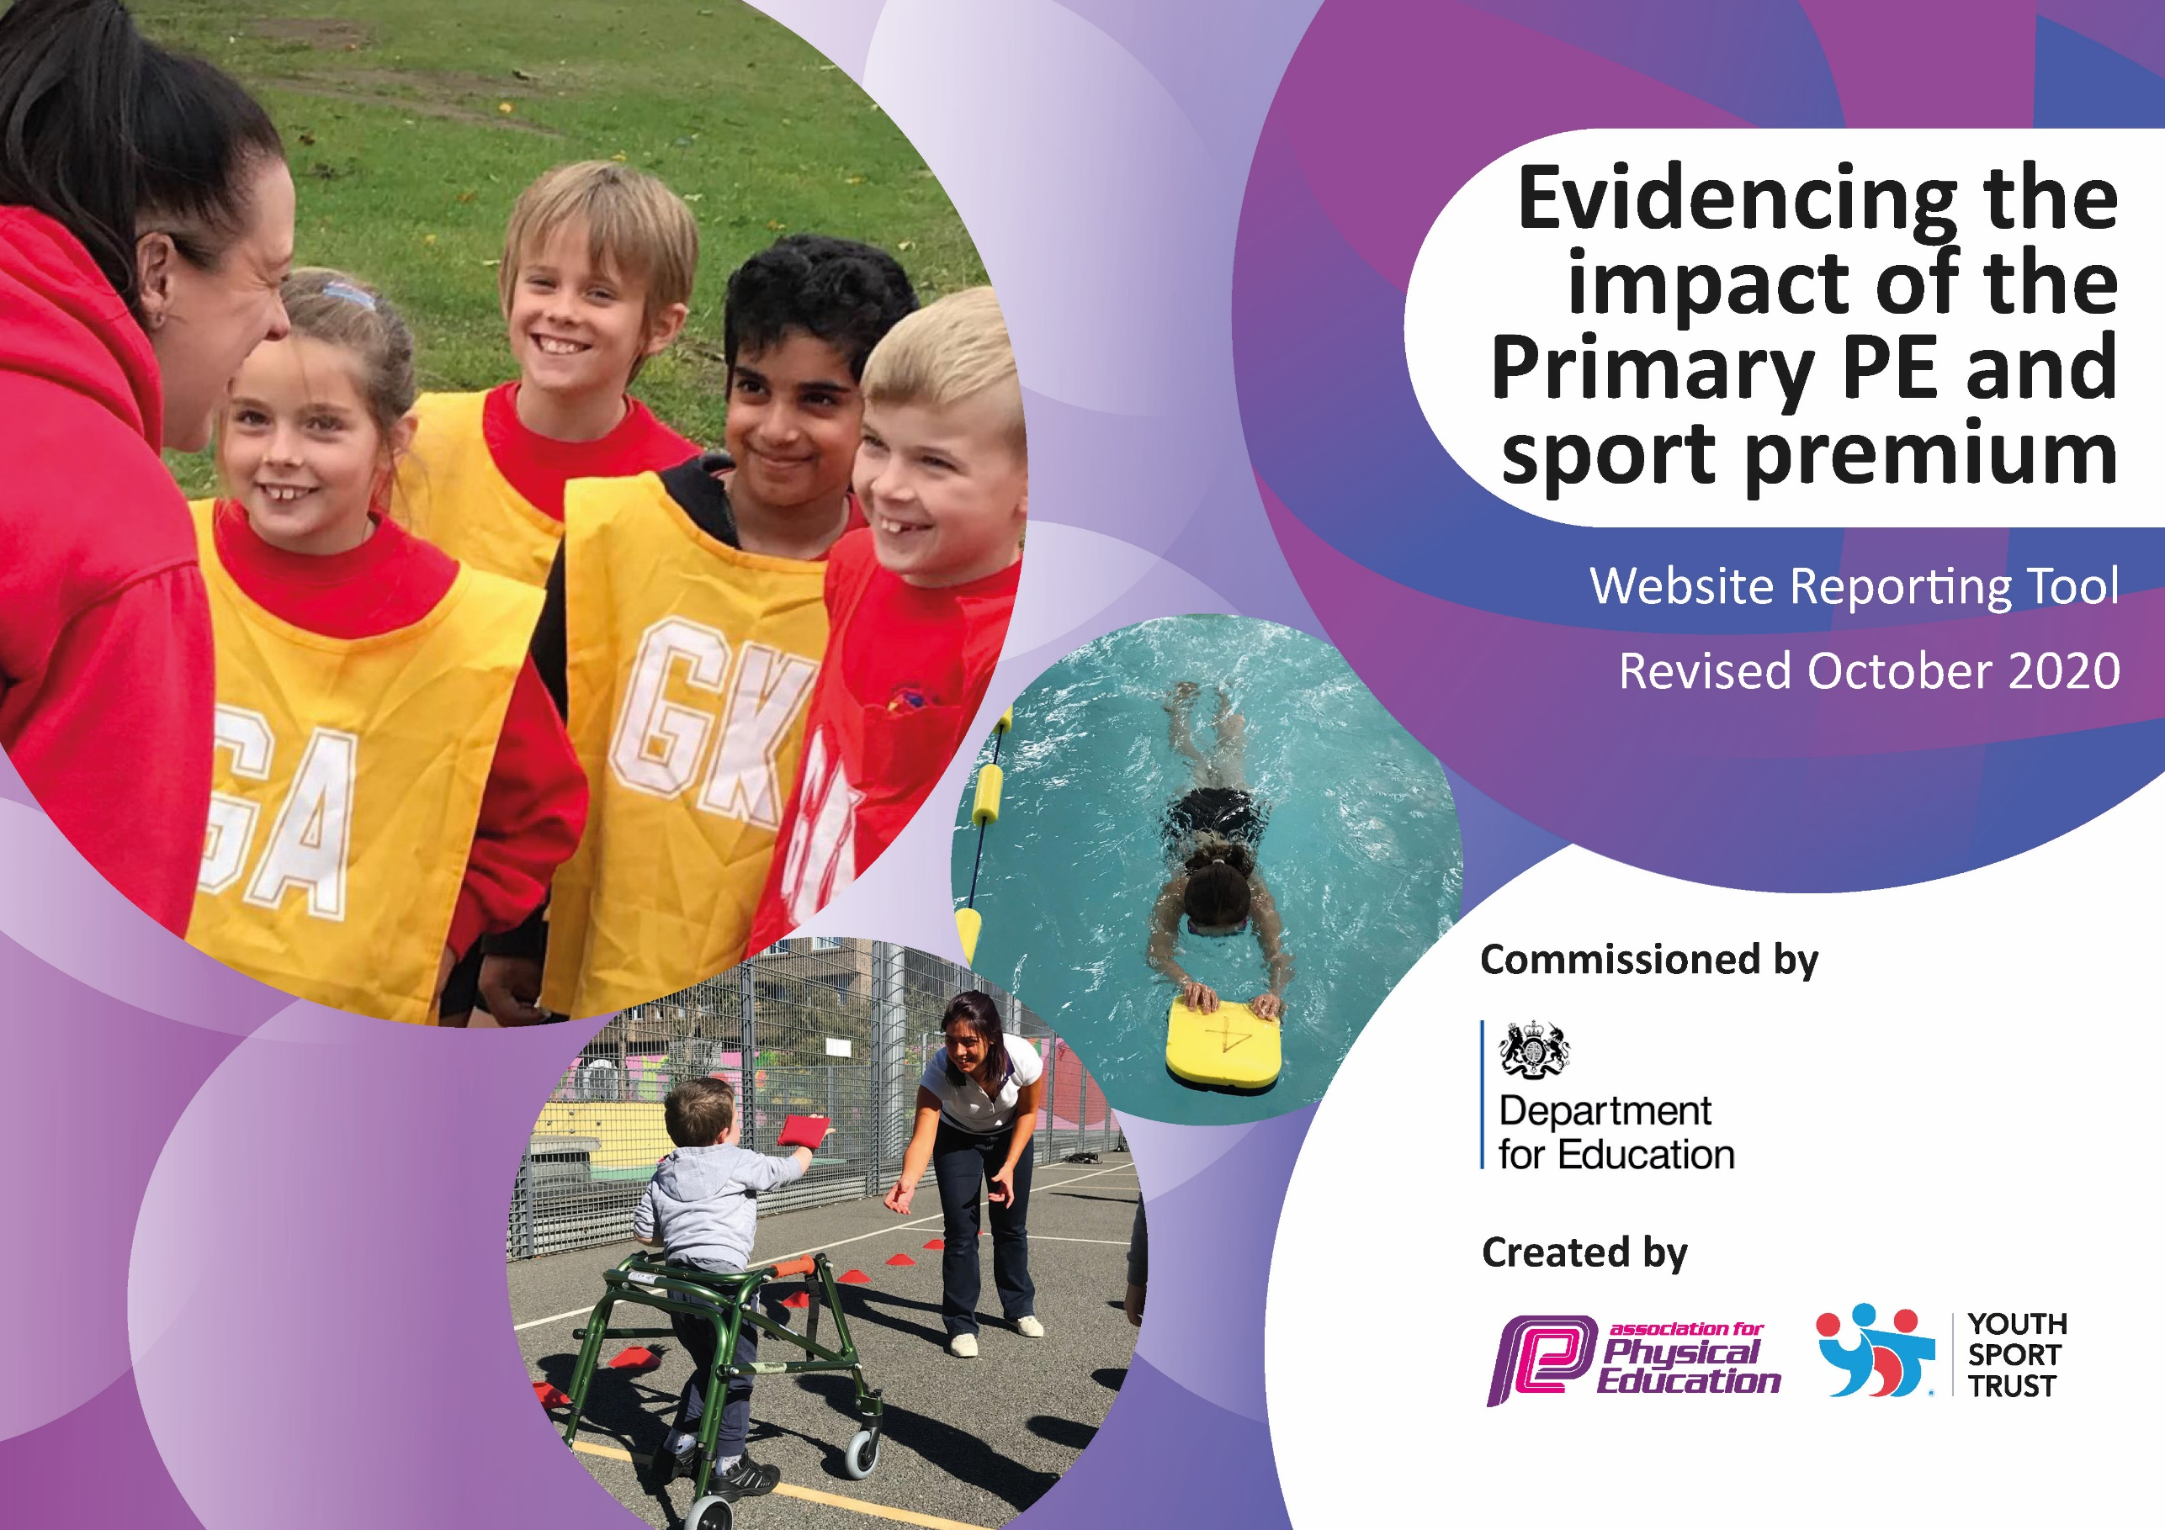
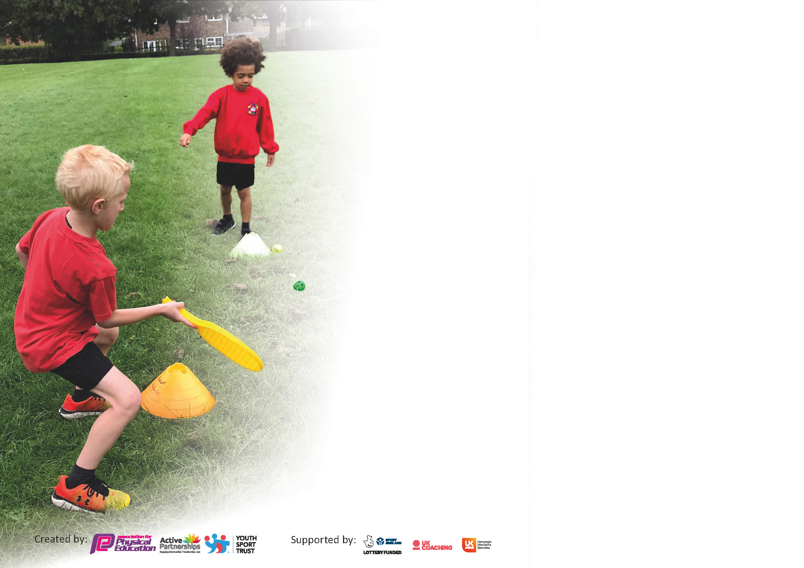

It is important that your grant is used effectively and based on school need. The Education Inspection Framework (Ofsted 2019 p64) makes clear there will be a focus on ‘whether leaders and those responsible for governors all understand their respective roles and perform these in a way that enhances the effectiveness of the school’.

Under the Quality of Education criteria (p41) inspectors consider the extent to which schools can articulate their curriculum (INTENT), construct their curriculum (IMPLEMENTATION) and demonstrate the outcomes which result (IMPACT).

To assist schools with common transferable language this template has been developed to utilise the same three headings which should make your plans easily transferable between working documents.

Schools must use the funding to make additional and sustainable improvements to the quality of Physical Education, School Sport and Physical Activity (PESSPA) they offer. This means that you should use
the Primary PE and sport premium to:

- Develop or add to the PESSPA activities that your school already offer
- Build capacity and capability within the school to ensure that improvements made now will benefit pupils joining the school in future years

Please visit gov.uk for the revised DfE guidance including the 5 key indicators across which schools should demonstrate an improvement. This document will help you to review your
provision and to report your spend. DfE encourages schools to use this template as an effective way of meeting the reporting requirements of the Primary PE and sport premium.

We recommend you start by reflecting on the impact of current provision and reviewing the previous spend.

Schools are required to publish details of how they spend this funding as well as on the impact it has on pupils’ PE and sport participation and attainment by the end of the summer term or by 31st July 2021 at the latest.

** In the case of any under-spend from 2019/20 which has been carried over this must be used and published by 31st March 2021.

We recommend regularly updating the table and publishing it on your website throughout the year. This evidences your ongoing self-evaluation of how you are using the funding to secure maximum, sustainable impact. Final copy must
be posted on your website by the end of the academic year and no later than the 31st July 2021. To see an example of how to complete the table please click HERE.
Created by: Supported by:

Support for review and reflection - considering the 5 key indicators from DfE, what development needs are a priority for your setting and your pupils now and why? Use the space below to reflect on previous spend and key achievements and areas for development.

N.B. In this section you should refer to any adjustments you might have made due to Covid-19 and how these will influence further improvement.
Key achievements to date until July 2020: | Areas for further improvement and baseline evidence of need:
- All children participate in 2 hours of PE lessons a week.  - Active 15 delivered at least 3 times a week.  - Increased uptake in those wanting to participate in the Coventry Children’s Mile.  - PE hub used to support delivery of curriculum and increase staff confidence.  - Wide range of extracurricular clubs offered.  - During lockdown home fitness challenges set.  - Intent, implementation and impact statement written.  - Piloted major inclusive dance project with Royal Opera House, to be rolled out to all schools as part of Coventry City of Culture.  - Reaccredited with School Games Silver Award.  - Arranged whole city inclusive sport and dance events and staff training.  - Increased opportunities to participate in competitive sport including School Games and inter school boys and girls football/netball/cross country.  - Gymnastic specialist teacher employed to support preparations for KS1 gymnastics competition.  - Re enrolled in SEND ACTIVE games to ensure we provide sporting opportunities for all in school including HIU and children with disabilities and learning difficulties.  - Pilot school for Travel to Tokyo family fitness program.  - Engagement with Commonwealth Games.  - Improved links with SGO leading to improved whole school PE provision.  - Strong links with LTA and Sport England leading to wide range of participation and spectating opportunities.  - Wider engagement with families through family fitness mornings at which parents have participated and volunteered to run sessions. | - Increase children’s activity levels again following lower levels of engagement during lockdowns.  - When restrictions allow provide targeted extracurricular sports clubs which provide competition for the more able and engage inactive children.  - Increase opportunities for family engagement by continuing to set physical activities/challenges during lockdowns/self-isolation periods.  - When restrictions allow engage families in sporting events at school and in the local community.  - No inter school competitions/tournaments due to Covid so will investigate how to provide increased opportunities for competition within school and virtual competitions/exercise opportunities with other schools.  - Fundamental movement skills are lower than expected therefore teachers will need to ‘fill the gaps’ as part of a recovery curriculum.  - Some children and adults may have mental health issues due to Covid so we will investigate ways to use exercise to improve mental health of all in school.  - Access to outdoor space and physical activity difficult for many families therefore we will investigate local exercise opportunities within our community and signpost these to families.  - Not participating in regular sport has resulted in lower levels of resilience and perseverance, teachers to address this as part of the recovery curriculum.  - Use pupil voice to find out what other exercise/sport opportunities children would like.  - No opportunity to provide swimming lessons last year therefore swimming lessons in Years 6, 5 and 4 will be a priority so that there are further opportunities in KS2 for children to achieve 25m.

Did you carry forward an underspend from 2019-20 academic year into the current academic year? YES/NO * Delete as applicable

If YES you must complete the following section
If NO, the following section is not applicable to you

If any funding from the academic year 2019/20 has been carried over you MUST complete the following section. Any carried over funding MUST be spent by 31 March 2021.
Academic Year: September 2020 to March 2021 | Total fund carried over: £  £4000 | Date Updated:
What Key indicator(s) are you going to focus on? |  |  |  | Total Carry Over Funding:
 |  |  |  | £
Intent | Implementation |  | Impact
To improve the provision of PE in school  To continue to up skill teachers.  To raise the profile of PE  To offer increased opportunities to participate in competitive sport.  To increase the after school provision. | To employ a Sports Engagement Manger | Carry over funding allocated: £4000 | Evidence of impact: How can you measure the impact on your pupils; you may have focussed on the difference that PE, SS & PA have made to pupils re-engagement with school. What has changed?: | Sustainability and suggested next steps and how does this link with the key indicators on which you are focussing this academic year?:

Meeting national curriculum requirements for swimming and water safety.

N.B Complete this section to your best ability. For example you might have practised safe self-rescue techniques on dry land.
What percentage of your current Year 6 cohort swim competently, confidently and proficiently over a distance of at least 25 metres?  N.B. Even though your pupils may swim in another year please report on their attainment on leaving primary school at the end of the summer term 2020. | 50%
What percentage of your current Year 6 cohort use a range of strokes effectively [for example, front crawl, backstroke and breaststroke]? | 50%
What percentage of your current Year 6 cohort perform safe self-rescue in different water-based situations? | 50%
Schools can choose to use the Primary PE and sport premium to provide additional provision for swimming but this must be for activity over and above the national curriculum requirements. Have you used it in this way? | No

Due to the impact of Covid-19 we have been unable to collate accurate data for last years Year 6 cohort or our current Year 6 cohort.

Action Plan and Budget Tracking
Capture your intended annual spend against the 5 key indicators. Clarify the success criteria and evidence of impact that you intend to measure to evaluate for pupils today and for the future.

Academic Year: 2020/21 | Total fund allocated: £10,121 | Date Updated:
Key indicator 1: The engagement of all pupils in regular physical activity – Chief Medical Officers guidelines recommend that primary school pupils undertake at least 30 minutes of physical activity a day in school |  |  |  | Percentage of total allocation:
 |  |  |  | %
Intent | Implementation |  | Impact
Your school focus should be clear what you want the pupils to know and be able to do and about  what they need to learn and to  consolidate through practice: | Make sure your actions to achieve are linked to your intentions: | Funding allocated: | Evidence of impact: what do pupils now know and what can they now do? What has changed?: | Sustainability and suggested next steps:
- All pupils to take part in at least 30 minutes of structured physical activity every school day.  - All children to access 2 x 1-hour high quality PE lessons a week.  - Most children to participate in increased physical activity through school and community clubs, including competition.  - More opportunities provided for active learning in all lessons to ensure that children are more active.  - Sports Leaders and apprentices to be positive role models for sport.  - Playtimes to include structured physical activity. | All children to take part in active 15 at least 3 times a week.  Investigate a half marathon running buddy, virtual initiative with Pearl Hyde.  Sports Engagement Manager to track all pupils’ daily activity through YST heatmap  Look into alternative funding for creating an all-weather track. Have an alternative field and playground route whilst funding is sought.  Ensure we have resources required for wide variety of PE lessons.  Staff aware of long term and medium term plans for PE.  Annual subscription to PE Hub.  PE Hub and Sports engagement manager to support staff with planning and resourcing their lessons.  Sports Engagement Manager to track whole school participation in school sports clubs and community sports clubs. This data to be used to provide targeted provision.  New wraparound care club to include specialist sport provision on 2 evenings, delivered by Sport Engagement Manager.  When restrictions ease gradually increase extracurricular activities. Use School council to ensure most popular clubs are prioritised.  Annual subscription to School Games and SEND Active.  Staff encouraged to use exercise as a way to boost mental health. Share good practices including Go Noodle, Just Dance, Jo Wicks etc. Incorporate ERASMUS ACTIVE project.  Subject leaders to plan in opportunities for active learning, within the whole curriculum. Christmas sport week consisting of fun challenges planned for December.  Look into alternative funding for creating an all-weather track. Have an alternative field and playground route whilst funding is sought.  Follow SGO guidelines for providing leadership opportunities in sport during Covid-19.  Sports leaders to make exercise challenge videos for classes to access.  Each class to have their own playtime equipment box.  Staff to engage children in structured games.  Sports leaders to lead activities when restrictions allow. | SEM: £4000  PE Hub: £455  SEM: £2000  SENDActive: £300  £500
Key indicator 2: The profile of PESSPA being raised across the school as a tool for whole school improvement |  |  |  | Percentage of total allocation:
 |  |  |  | %
Intent | Implementation |  | Impact
Your school focus should be clear what you want the pupils to know and be able to do and about  what they need to learn and to  consolidate through practice: | Make sure your actions to achieve are linked to your intentions: | Funding allocated: | Evidence of impact: what do pupils now know and what can they now do? What has changed?: | Sustainability and suggested next steps:
- Pupils and families to understand importance of being active and participating in sport.  - Raised awareness in school of sporting opportunities in the local community.  - Raise the profile of sporting competition in school by providing intra-school competitions  - Celebrate sporting success  - Continue to champion Inclusive sport | Lockdown and self-isolation activities to include an emphasis on using exercise as a way of improving our mental and physical well-being. When restriction ease, invite families to join in physical activities with their children.  New format sports day to be repeated and adapted to include new equipment  New high profile sports noticeboards with details of fixtures and photos of events.  Half termly newsletters to school community about sports events. Swimming lessons moved to Alan Higgs as it is more local facility. Organise termly well-being activities in the local community for each class e.g. Foot Golf at War Memorial Park.  Sports Engagement Manager to organize and track participation in intra school competitions.  Maintain and update sport displays.  Howes Gets Fit – socially distanced fitness training inter-class competition. Launched with assembly in September.  Sport achievement assemblies including celebrating intra-school competitions. Individual prizes and class trophy for winners of Howes Gets Fit.  Half termly newsletters to include sporting successes.  Lead whole city dance project. Annual subscription to SEND Active | £1000  £850

Key indicator 3: Increased confidence, knowledge and skills of all staff in teaching PE and sport |  |  |  | Percentage of total allocation:
 |  |  |  | %
Intent | Implementation |  | Impact
Your school focus should be clear | Make sure your actions to | Funding | Evidence of impact: what do | Sustainability and suggested
what you want the pupils to know | achieve are linked to your | allocated: | pupils now know and what | next steps:
and be able to do and about | intentions: |  | can they now do? What has
what they need to learn and to |  |  | changed?:
consolidate through practice:
- Raise the quality of PE teaching throughout the school and ensure skills progression.  - Adapt curriculum according to current COVID-19 restrictions.  - Staff are confident teaching all abilities including those with specific sporting talents and children with additional needs. | Annual subscription to PE Hub. Teachers to use video links to improve delivery of skills.  Teachers to actively use skills progression tracker for their year group.  Use of technology and online learning to develop staff confidence.  Use of Sport Engagement Manager for coaching staff and advice.  Use of SGO to inform and develop PE team.  Long term plan to be adapted termly.  Socially distanced fitness training activities from PE Hub to be included.  PE team, SGO and Send Active team to provide support to ensure an inclusive curriculum.  STEP principal to be applied by all staff to differentiate lessons. | Equipment: £1000
Key indicator 4: Broader experience of a range of sports and activities offered to all pupils |  |  |  | Percentage of total allocation:
 |  |  |  | %
Intent | Implementation |  | Impact
Your school focus should be clear | Make sure your actions to | Funding | Evidence of impact: what do | Sustainability and suggested
what you want the pupils to know | achieve are linked to your | allocated: | pupils now know and what | next steps:
and be able to do and about | intentions: |  | can they now do? What has
what they need to learn and to |  |  | changed?:
consolidate through practice:
Additional achievements:  - Improve mental health and wellbeing  - Children to have opportunities to participate in sport in the community.  - Equipment to support introduction of new sports  - Increase % of children able to swim 25m.  - Provide opportunities for inclusive sport | Investigate organising trips to local sporting venues e.g. Foot golf at War Memorial Park.  More effective use of wider environment  Introduce children to activities which are sustainable at home e.g. Joe Wicks/Go Noodle  Look into alternative funding for creating an all-weather track. Have an alternative field and playground route whilst funding is sought.  Investigate organising trips to sporting venues in the local community. Eg Foot Golf at the War Memorial Park, to encourage families to access in their spare time  Swimming lessons at Alan Higgs as it is a more local venue.  Purchase indoor athletics resources including speed bounce mat.  Provide Swimming lessons to more pupils in KS2.  Dance program  SEND Active subscription  Sports Engagement Manager to identify G&T children and concessions made for them to attend clubs.

Key indicator 5: Increased participation in competitive sport |  |  |  | Percentage of total allocation:
 |  |  |  | %
Intent | Implementation |  | Impact
Your school focus should be clear | Make sure your actions to | Funding | Evidence of impact: what do | Sustainability and suggested
what you want the pupils to know | achieve are linked to your | allocated: | pupils now know and what | next steps:
and be able to do and about | intentions: |  | can they now do? What has
what they need to learn and to |  |  | changed?:
consolidate through practice:
- Participate in School Games competitions  - Participate in SEND Active activities  - Increase Intra-school competitions. | School Games annual subscription and virtual participation. Participation to be monitored by Sports Engagement Manager.  SEND Active annual subscription  Kurling tournament  Participation to be monitored by Sports Engagement Manager.  Termly intra-class, inter-class, inter house competitions.  Howes Gets Fit fitness challenge.  Participation to be monitored by Sports Engagement Manager.  Christmas games competition organised for December.

Signed off by
Head Teacher:
Date:
Subject Leader:
Date:
Governor:
Date:

