Ash Class Year 1 & Year 2
Ash@howes.coventry.sch.uk
1st March – 5th March
No Screen/ World Book Day 4/3/21

Online lessons will be on Monday and Friday;
Year 1 – 11.00am – 11.30am
Year 2 - 11.40am and 12.10pm.
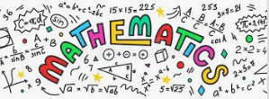 | Y1 White Rose Maths Workbook (Addition & Subtraction within 20);  Pages 2 - 10  Y2 White Rose Maths Workbook (Multiplication & Division;) Pages 2 - 13.
Y1 CGP English Comprehension book; Pages 1 & 2.
Y1 CPG Phonics Buster book; Pages 1, 2 & 3.
Written Task; Write 4 sentences in your work book to describe what the children are doing in the park (picture in Comprehension book).

Y2 CGP English Comprehension book; Pages 2 & 3.
Y2 CPG Grammar, Punctuation & Spelling; Pages 1 & 2.
Written Task; Follow a recipe/ set of instructions to make something. In your work book write about what you did and explain how easy/ difficult it was. How could you improve the instructions?

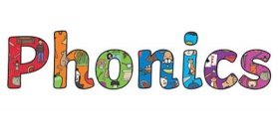 | Phase 4 ew/ er Phase 5 wh/ ph  blew whisper  grew whistle  flew wheel  chew whenever  after white  flower phonics  over sphinx  mother dolphin  her phantom  out elephant  asked  what  Activities to help practise your spellings:  - Write each spelling out 3 times.  - Rainbow write them. 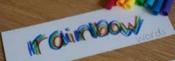  - write them.  - Play hangman with a grown up. 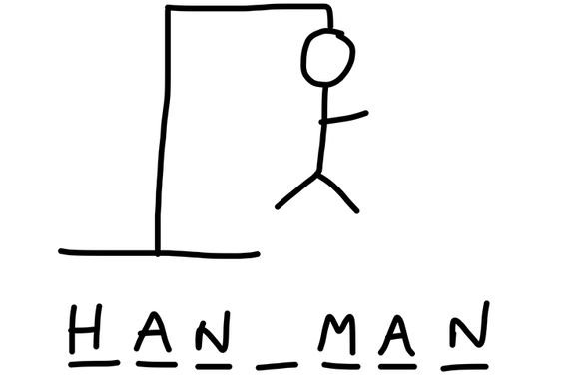  - Get someone to test you.  *Please email your test score each week!
No-Screen Day/ World Book Day  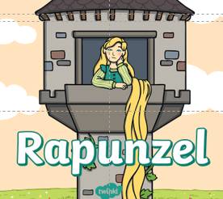 | Tasks:  - Read/ listen to the story of Rapunzel.  - Using the task sheet from your topic pack have a go at designing and making a tower which allows Rapunzel to escape the witch.  - Using the puppets from your topic pack then have a go at retelling the story.  - You could then use the story board template to have a go at then re-writing an alternative version of the story, where Rapunzel escapes.  - Using the ideas from the Non-screen activities you can do at home have a go at building a reading den.  - Crawl inside your den & enjoy reading your new version of Rapunzel.  *You could work with your brothers/ sisters to build the den  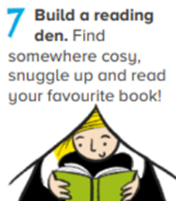  Now choose 2 more activities you would like to do from the ideas list.
P.E: 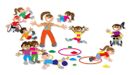 | PE Challenge: See how many of each of the following activities you can complete in 30 seconds; Star jumps, burpees, squats, sit-ups, press-ups, high knees, leg raises, side to sides & how long can you hold the plank?  *Keep a record and see if you can improve each week.
Please remember to go to the lessons on the official Department for Education Oak National Academy website https://www.thenational.academy/
Select your year group and subject, watch the lesson and do the activity.
- If you are running out of reading material, there are lots of free reading books being offered on line. You can browse by age or reading level and access them on lots of devices.
https://home.oxfordowl.co.uk/reading/free-ebooks/
*Be prepared to share a ‘book recommendation’ in our feedback session on Friday -it could be a book you have at home or one from Oxford Owl that you really enjoyed & think others would enjoy too.

