Ash Class Year 1 & Year 2
Ash@howes.coventry.sch.uk
22nd February – 26th February

Online lessons will be on Monday and Friday;
Year 1 – 11.00am – 11.30am
Year 2 - 11.40am and 12.10pm.
Y1 White Rose Maths Workbook pages 46 – 53.
Y2 White Rose Maths Workbook pages 52 – 67.

Y1 CGP English workbook pages 42 – 49.
Y2 CGP English workbook pages 42 - 49.

Phase 4  ee/ oa | Phase 5  ow/ aw
green | flower
steep | brown
tree | frown
creep | clown
speech | drown
groan | draw
loan | straw
moan | claw
you | lawn
are | dawn
 | when
 | what
Activities to help practise your spellings:
- Write each spelling out 3 times.
- Rainbow write them.
- write them.
- Play hangman with a grown up. 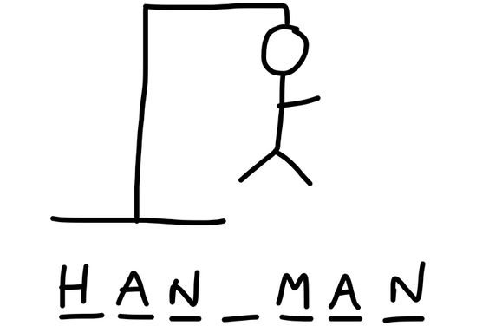
- Get someone to test you.
*Please email your test score each week!
Topic:  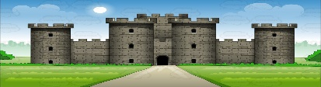  Towers, Tunnels and Turrets. | Tasks: Why were castles built where they were?  - Investigating maps -mark where you would build a castle on the map and explain why you would locate it here.  - Explain the location of the bridge and list all of the different materials that the bridge could be made from.  - Design a bridge which can cross the river. Why did you choose this design?
P.E: | PE Challenge: See how many of each of the following activities you can complete in 30 seconds; Star jumps, burpees, squats, sit-ups, press-ups, high knees, leg raises, side to sides & how long can you hold the plank?  *Keep a record and see if you can improve each week.
Please remember to go to the lessons on the official Department for Education Oak National Academy website https://www.thenational.academy/
Select your year group and subject, watch the lesson and do the activity.
- If you are running out of reading material, there are lots of free reading books being offered on line. You can browse by age or reading level and access them on lots of devices.
https://home.oxfordowl.co.uk/reading/free-ebooks/
*Be prepared to share a ‘book recommendation’ in our feedback session on Friday -it could be a book you have at home or one from Oxford Owl that you really enjoyed & think others would enjoy too.

