Ash Class Year 1 & Year 2
Ash@howes.coventry.sch.uk
8th February – 12th February

Online lessons will be on Monday and Friday;
Year 1 – 11.00am – 11.30am
Year 2 - 11.40am and 12.10pm.
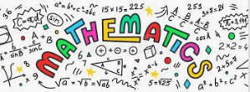 | Y1 White Rose Maths Workbook pages 35 – 45.  Y2 White Rose Maths Workbook pages 38 – 51.
Y1 CGP English workbook pages 34 – 41.
Y2 CGP English workbook pages 34 – 41.

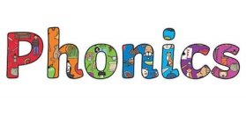 | Phase 4 -oa/ -ea Phase 5 air/ ea  roast stairway  toast hair  coast chair  beast fair  yeast pair  feast speak  least beach  crease clean  they reading  her heating  were  There  Activities to help practise your spellings:  - Write each spelling out 3 times.  - Rainbow write them. 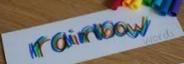  - write them.  - Play hangman with a grown up. 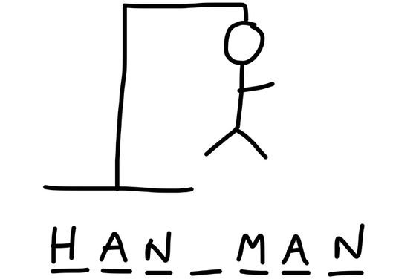  - Get someone to test you.  *Please email your test score each week!
Topic:  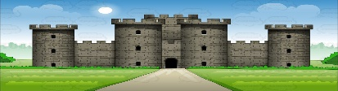  Towers, Tunnels and Turrets. | Tasks: Design a coat of arms.  - Design and create a coat of arms for your family, thinking about the symbolism of the colours/ animals used.  - Complete differentiated castles and knights word search.  *Use worksheets from your topic pack.
P.E: 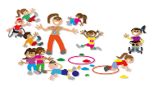 | PE Challenge: See how many of each of the following activities you can complete in 30 seconds; Star jumps, burpees, squats, sit-ups, press-ups, high knees, leg raises, side to sides & how long can you hold the plank?  *Keep a record and see if you can improve each week.
Please remember to go to the lessons on the official Department for Education Oak National Academy website https://www.thenational.academy/
Select your year group and subject, watch the lesson and do the activity.
- If you are running out of reading material, there are lots of free reading books being offered on line. You can browse by age or reading level and access them on lots of devices.
https://home.oxfordowl.co.uk/reading/free-ebooks/
*Be prepared to share a ‘book recommendation’ in our feedback session on Friday -it could be a book you have at home or one from Oxford Owl that you really enjoyed & think others would enjoy too.

