Ash Class Year 1 & Year 2
Ash@howes.coventry.sch.uk
1st February – 5th February

Online lessons will be on Monday and Friday;
Year 1 – 11.00am – 11.30am
Year 2 - 11.40am and 12.10pm.
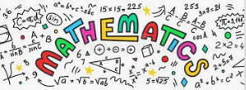 | Y1 White Rose Maths Workbook pages 24 – 34.  Y2 White Rose Maths Workbook pages 26 – 37.
Y1 CGP English workbook pages 26 – 33.
Y2 CGP English workbook pages 26 – 33.

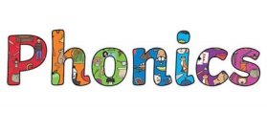 | Phase 4 -ft/ -ss Phase 5 or/ ay  drift storm  gift morning  lift horse  swift short  hiss sport  kiss always  miss today  less replay  down dismay  be help  said  it’s  Activities to help practise your spellings:  - Write each spelling out 3 times.  - Rainbow write them. 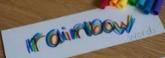  - write them.  - Play hangman with a grown up. 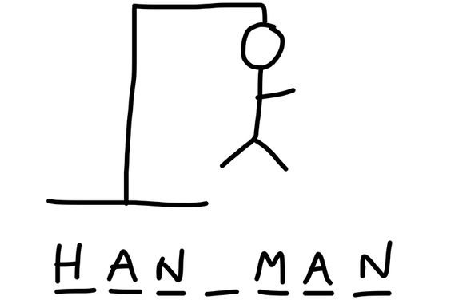  - Get someone to test you.  *Please email your test score each week!
Topic:  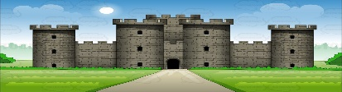  Towers, Tunnels and Turrets. | Task: Take a virtual tour of Warwick Castle http://historyview.org/library/warwick-castle/ Think about the people that lived in the castle and what jobs they did.  - Complete ‘label the knight’s armour’ worksheet from your topic pack.  - Create a chart/ presentation/ list of the other jobs that people did (Lord/ Lady, servants, cook, soldiers, jester etc). See video of online learning for examples.
P.E: 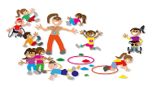 | PE Challenge: See how many of each of the following activities you can complete in 30 seconds; Star jumps, burpees, squats, sit-ups, press-ups, high knees, leg raises, side to sides & how long can you hold the plank?  *Keep a record and see if you can improve each week.
Please remember to go to the lessons on the official Department for Education Oak National Academy website https://www.thenational.academy/
Select your year group and subject, watch the lesson and do the activity.
- If you are running out of reading material, there are lots of free reading books being offered on line. You can browse by age or reading level and access them on lots of devices.
https://home.oxfordowl.co.uk/reading/free-ebooks/
*From next week in our online feedback sessions (Friday) we are going to include a ‘book recommendation’ section, it could be a book you have at home or one from Oxford Owl that you really enjoyed & think others would enjoy too.

