Ash Class Year 1 & Year 2
Ash@howes.coventry.sch.uk
25th – 29th January

Online lessons will be on Monday and Friday;
Year 1 – 11.00am – 11.30am
Year 2 - 11.40am and 12.10pm.
Y1 White Rose Maths Workbook pages 15 – 23.
Y2 White Rose Maths Workbook pages 18 – 25.

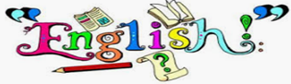 | Y1 CGP English workbook pages 18 -25.  Y2 CGP English workbook pages 18 -25.
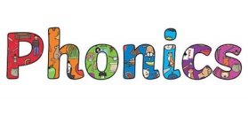 | Phase 4 -ill/ -ff Phase 5 o-e/ u-e  bill hole  fill hope  hill nose  will joke  cliff home  sniff tube  huff tune  puff chute  will use  was come  some  children  Activities to help practise your spellings:  - Write each spelling out 3 times.  - Rainbow write them. 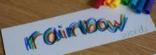  - write them.  - Play hangman with a grown up. 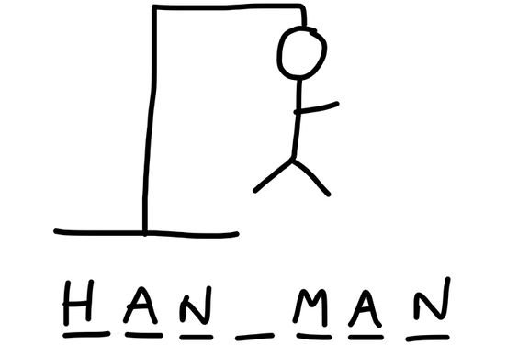  - Get someone to test you.  *Please email your test score each week!
Topic:  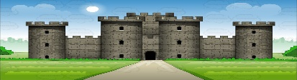  Towers, Tunnels and Turrets. | Task: Complete differentiated reading comprehension about Castles.  - Read through the fact file.  - If you don’t understand any of the words that are used look them up in a dictionary, ask an adult or use the internet to find out.  - Begin answering the questions in full sentences.  Remember, you can use a coloured pencil/ highlighter to help retrieve the answers from the text –just like we do in school!
Please remember to go to the lessons on the official Department for Education Oak National Academy website https://www.thenational.academy/
Select your year group and subject, watch the lesson and do the activity.
- If you are running out of reading material, there are lots of free reading books being offered on line. You can browse by age or reading level and access them on lots of devices.
https://home.oxfordowl.co.uk/reading/free-ebooks/

