Ash Class Year 1 & Year 2
Ash@howes.coventry.sch.uk
18th – 22nd January

Online lessons will be on Monday and Friday between 11.40am and 12.10pm.
Y1 White Rose Maths Workbook pages 8 – 14.
Y2 White Rose Maths Workbook pages 10 – 17.

Y1 CGP English workbook pages 10 – 17.
Y2 CGP English workbook pages10 – 17.

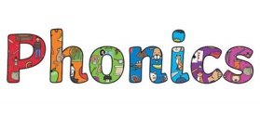 | Phase 4 -ll Phase 5 i-e  ball bike  call time  wall wise  fell kite  tell inside  well like  all mine  be bite  size  beside  like  from  Activities to help practise your spellings:  - Write each spelling out 3 times.  - Rainbow write them. 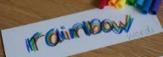  - write them.  - Play hangman with a grown up. 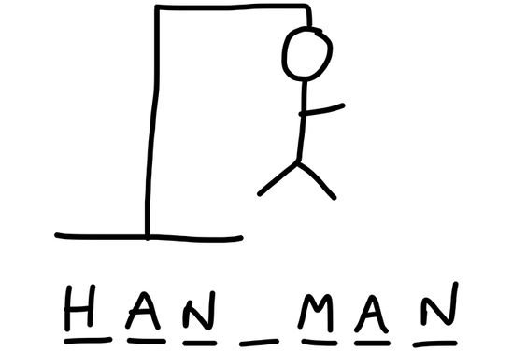  - Get someone to test you.  *Please email your test score each week!
Topic:  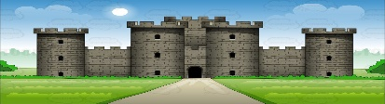  Towers, Tunnels and Turrets. | Task: Design and build a model castle.  - Re-watch the film clip from last week;  https://www.youtube.com/watch?v=RXXDThkJ3Ew  Alternatively, you could look at images from the internet and think about how castles were designed.  - Use the planning sheet from your pack to help design your own castle.  - Using either junk modelling materials (cardboard boxes & tubes), paper templates provided in your topic pack or even lego, have a go at building your own castle.  - Think about including the following features:  Towers  Battlements  Castle gate with a drawbridge  Portcullis  Arrow slits  - If you have some Knights, horses or princess toys you could even use this role a small world role-pay.
Please remember to go to the lessons on the official Department for Education Oak National Academy website https://www.thenational.academy/
Select your year group and subject, watch the lesson and do the activity.
- If you are running out of reading material, there are lots of free reading books being offered on line. You can browse by age or reading level and access them on lots of devices.
https://home.oxfordowl.co.uk/reading/free-ebooks/

