Ash Class Year 1 & Year 2
Ash@howes.coventry.sch.uk
11th – 15th January

Online lessons will be on Monday and Friday between 11.40am and 12.10pm.
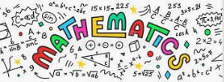 | Y1 White Rose Maths Workbook pages 2 – 7.  Y2 White Rose Maths Workbook pages 2 – 9.
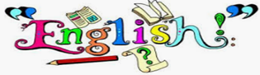 | Y1 CGP English workbook pages 2 – 9.  Y2 CGP English workbook pages 2 – 9.
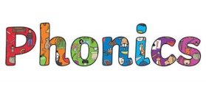 | Phase 4 -ck Phase 5 a-e  pack made  sack make  sick came  rock gate  sock gave  luck cake  them take  they name  late  wave  have  went  Activities to help practise your spellings:  - Write each spelling out 3 times.  - Rainbow write them. 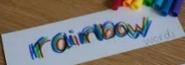  - write them.  - Play hangman with a grown up. 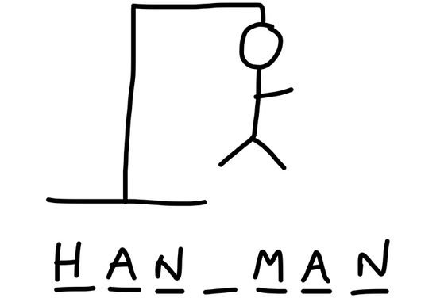  - Get someone to test you.  *Please email your test score each week!
Topic:  Towers, Tunnels and Turrets. | Using the information sheets within your pack, read about the different parts of a castle and what their purpose was.  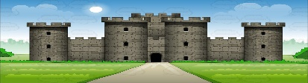  - Label the parts of the castle on the worksheet provided.  - Complete the features of a castle worksheet explaining what the different parts of a castle were for.  This short film clip will help to explain further.  https://www.youtube.com/watch?v=RXXDThkJ3Ew
Please remember to go to the lessons on the official Department for Education Oak National Academy website https://www.thenational.academy/
Select your year group and subject, watch the lesson and do the activity.

