Reception and Nursery
18th – 22nd January

Online lessons will be on Monday and Friday between 12.20pm and 12.40pm.
Sing the alphabet: Zed' version https://www.youtube.com/watch?v=ycnPbp_CrVg
Practise phase 2 phonemes: https://www.youtube.com/watch?v=J8KR8ThoPl4
CGP Phonics 10 – minute weekly workouts book: Workouts 7 & 8 p14- p17.
Watch the story of The Gruffalo on Books Alive YouTube: https://www.youtube.com/watch?v=JOH_IaAWMMk
Complete the worksheet on sequencing the story, of The Gruffalo. Can you retell it in your own words?
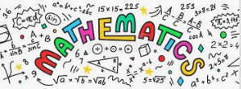 | Can you name and talk about 2D shapes? Complete as many tasks on the 2D sheet that you can. I like making shapes with different objects.
Learning activities | Winter: Build a sledge for a small toy using household materials  Help the birds by scooping out the inside of an orange and filling it with bird seed. https://www.youtube.com/watch?app=desktop&v=VWFmhCkawnI  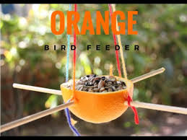
Please remember to go to the lessons on the official Department for Education Oak National Academy website https://www.thenational.academy/
Select your year group and subject, watch the lesson and do the activity.

