Summer 2 - Road Trip USA Part 2 – The Greatest Show!!
Week | Key question | English | Reading | Maths | Science | Creative
Introduction |  | Watch https://www.youtube.com/watch?v=B-7uPEtl7RM
1 | Would you like to join the circus? | Describe a circus setting.  Use the picture at the bottom of this plan to write a paragraph describing a circus setting. Remember to use all your senses: what would you see, hear, small, feel? | Comprehension  The Day the Clown Went to The Zoo  (DOES NOT need to be printed)  Read the extract and answer the given questions either on paper or verbally to an adult.  There are 3 levels of difficulty (* rating). Choose the right level of difficulty for you.  LINK  https://www.twinkl.co.uk/resource/cfe-l-121-cfe-first-level-the-day-the-clown-went-to-the-zoo-differentiated-reading-comprehension-activity | Money  Amy went into her local stationery shop. Her mum had given her £2.50 to spend.  Amy liked the look of some luminous pens, which cost 15p each, and some fancy pencils, which cost 10p each.  1) How much do 3 pens and 2 pencils cost? What would her change be?  Challenge:  She bought four times as many pens as pencils and was given 40p change.  How many of each did she buy?  Time  Make a plan for your day at the circus. Write a list of everything you’d do that day. E.g. get up and have breakfast, drive to the circus, watch the clowns, buy some snacks Next write down how long will you do each activity? E.g 30 minutes. Draw cocks to show what time each activity starts. | Rainbow snake bubbles  Watch and follow Ryan from Ryan’s Toy Review  https://www.youtube.com/watch?v=iZON2cN_Szc | HISTORY  http://www.historyofcircus.com  Read about the history of the circus. Then, create a timeline.  Art  Recreate old circus poster. See image at the bottom of this plan.  PSHE  Kindness: Draw a picture of a heart on a piece of paper. Think of all kind acts people do for you and on one side of the heart colour in a patch of your heart, a different colour for each act. Things like when your sibling plays with you or your parent or carer cooks food that you like. Add all the kind things that you do for other people that also make you happy on the other side of the heart. Maybe you call your grandparents or tidy up all your toys. Keep going until your heart is full.  PE  FEED THE ELEPHANTS:  https://theinspiredtreehouse.com/fine-motor-activities-feed-elephant/  Drama  Mime acts are popular in circus’.  Watch this tutorial and have a go at creating your own. Maybe you could make a video and send it to us?  https://www.youtube.com/watch?v=Mb_y4agvt_g  Music  Follow the circus music lesson ppt in the resources section  PE  Juggling  Scarf Juggling  https://www.youtube.com/watch?v=ve2FKNctOBg  (Use scarves, squares of material or even tissues)  Watch this link to learn how to juggle 3 balls: https://www.youtube.com/watch?v=2adm_33hGmU  (You could use rolled up socks)  PSHE  Laughter – read these circus jokes. Try to make someone laugh.  https://www.enchantedlearning.com/jokes/topics/circus.shtml  Art  Create a balloon finger painting  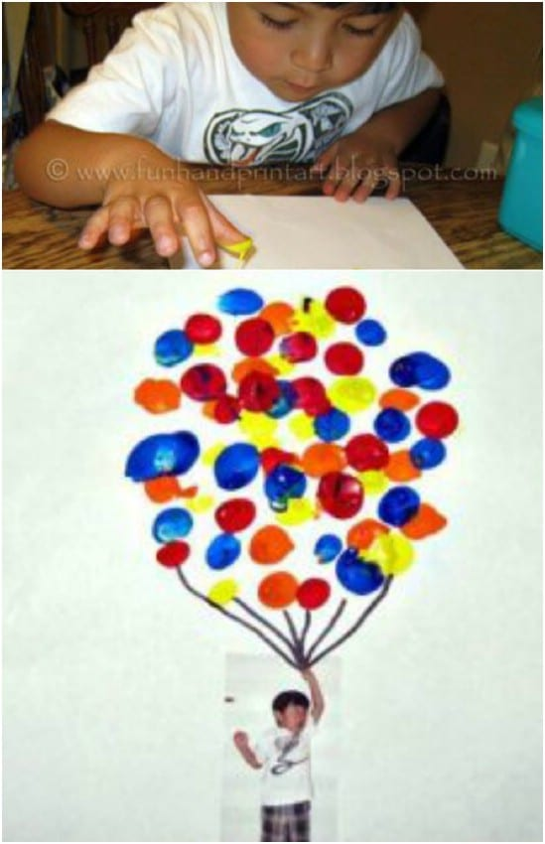  Art  Colour mixing  Watch the video and then have a go at making your own rainbow pen. When you’ve done that see what other colour pens you can make by mixing just two colours together. Make a prediction what colour do you think they’ll make? Were you right?  https://www.youtube.com/watch?v=Utmn0IPitlg  PSHE  How are you feeling?  Make up some new emojis.  You could try drawing an emoji for every day of the week  to record how you are feeling (you could put the date  on the back) and keep them like a diary.  You could make some paper plate emojis (see picture  below) and then whenever you have a certain feeling, you  could put the plate on display somewhere for your parent to  see –then you can share your feelings.  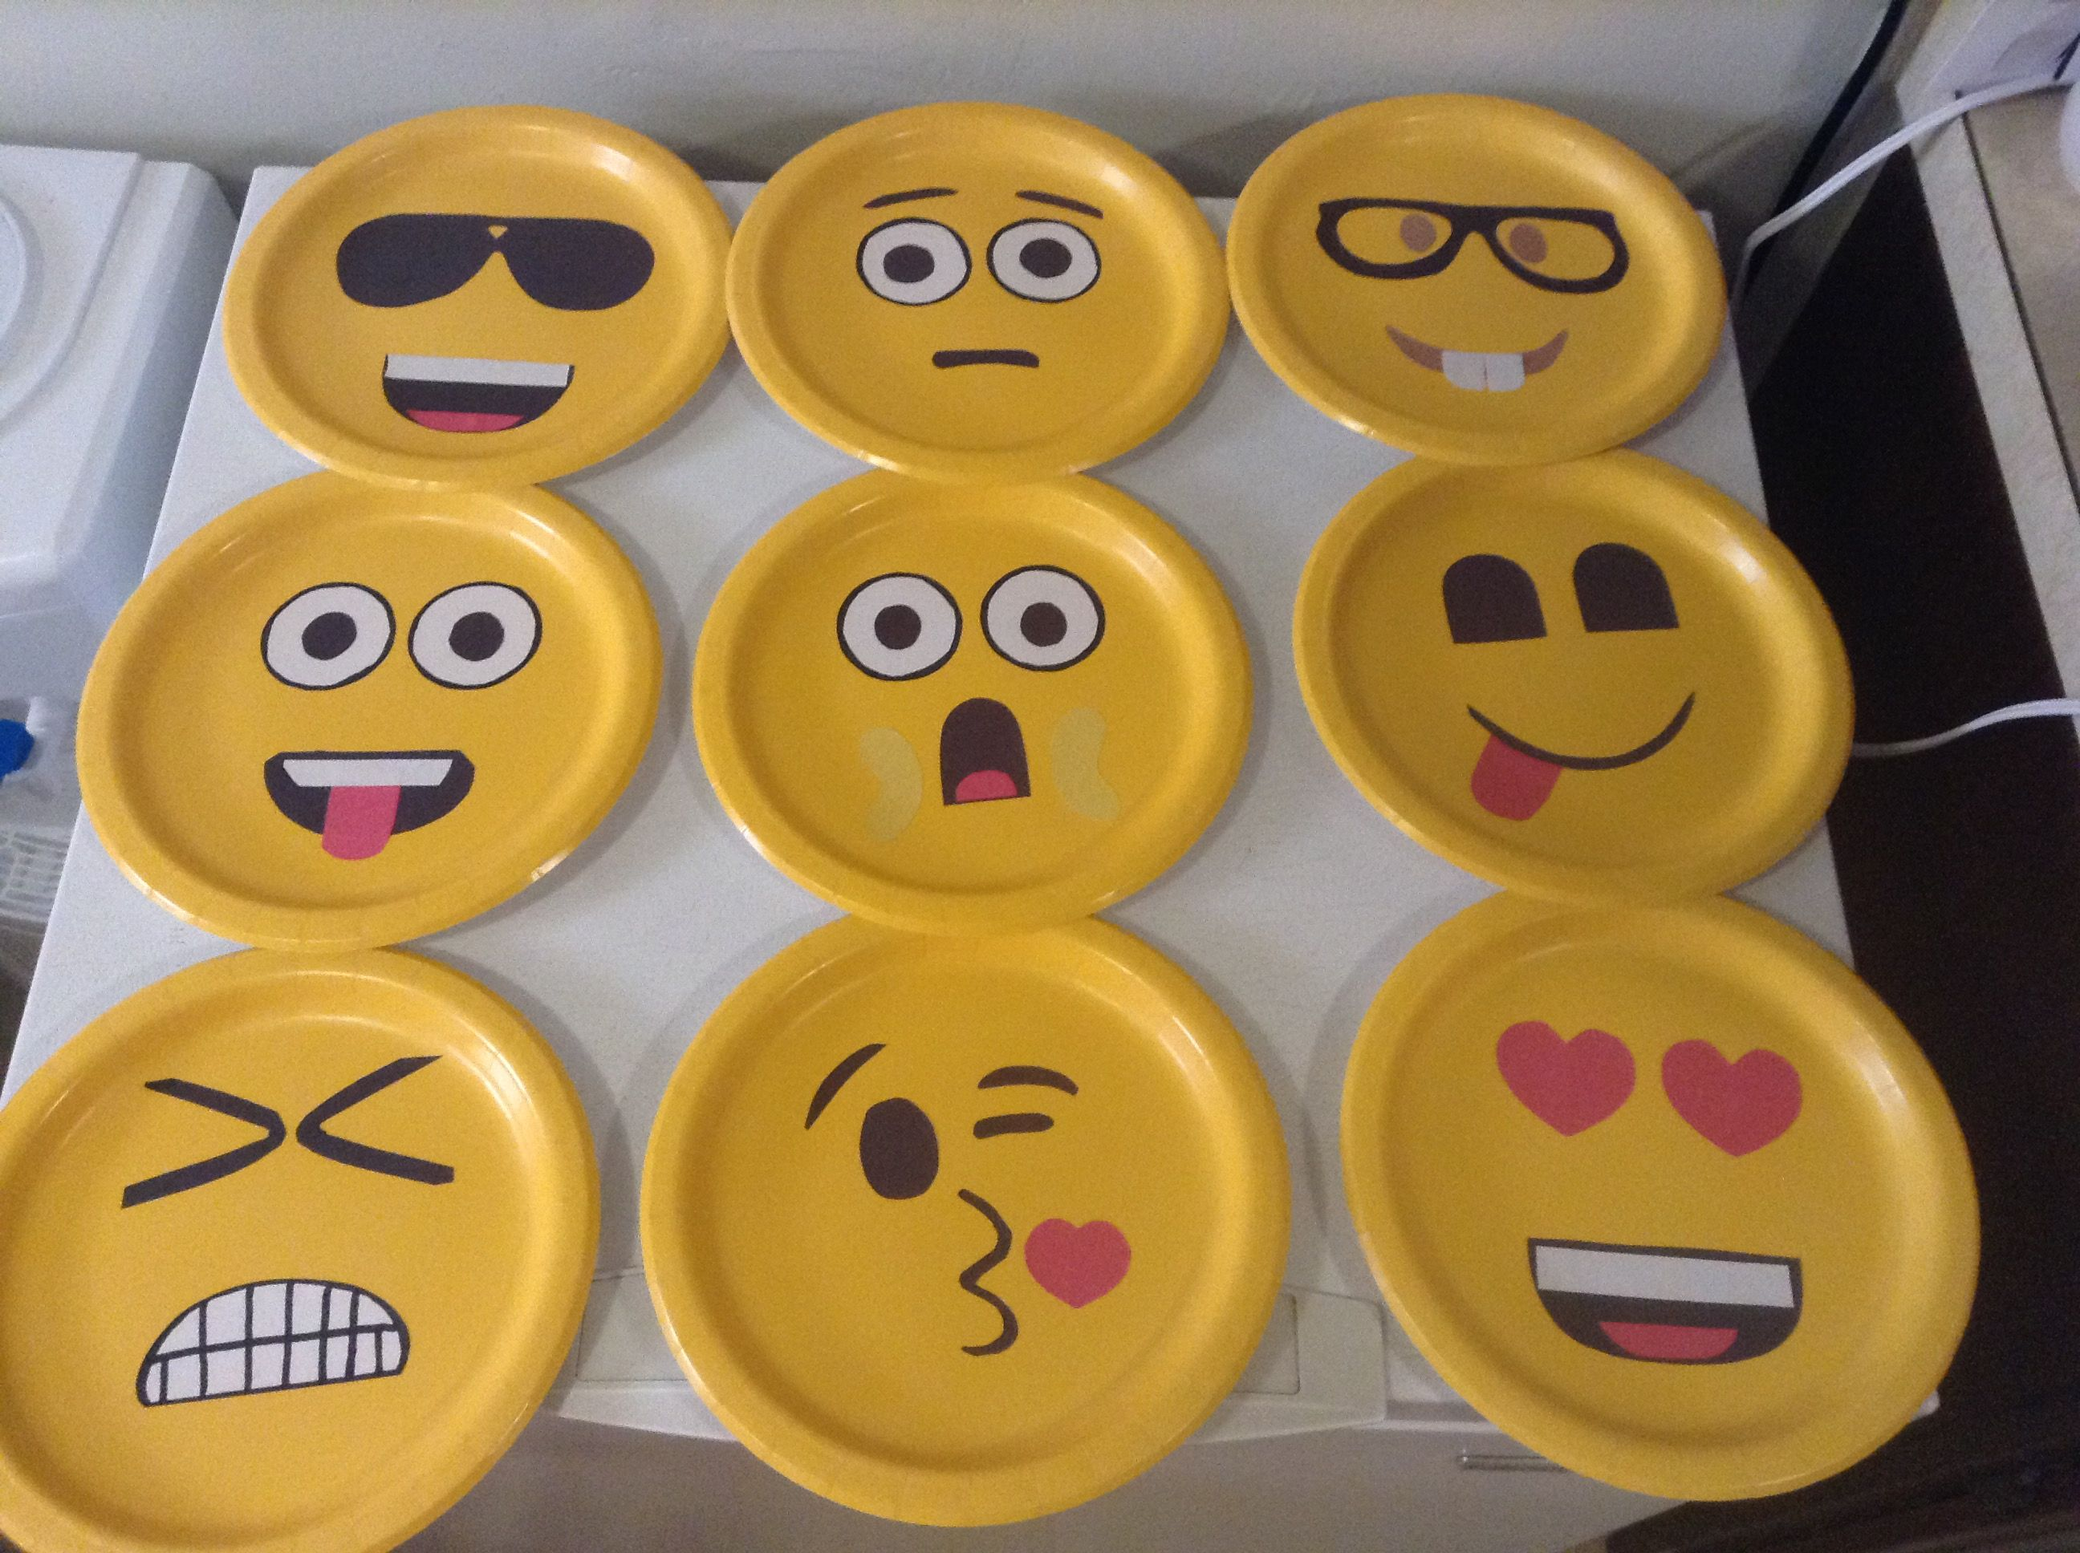  Watch Dumbo  Watch the Greatest Showman
2 |  | Story – Let the dice decide!!  Use the story planner dice activity found in the resources section to help you plan and write a story set at the circus. Use your setting description from last week to help.  https://www.twinkl.co.uk/resource/t-t-27949-circus-story-writing-activity | https://www.youtube.com/watch?v=HbI-V0Bbc5U  Listen to Olivia Saves the Circus.  Can you read a story aloud? Maybe you could ask an adult to film you and you could send us your videos. We would love to see them. Or use face time and show it to a friend and then watch theirs. | School Fair Necklaces – Problem Solving  Rob and Jennie were making necklaces to sell at the school fair. They decided to make them very mathematical.  Each necklace was to have eight beads, four of one colour and four of another and each had to be symmetrical, like this.  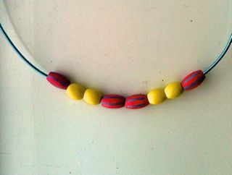  How many different necklaces could they make?  Can you find them all?  How do you know there aren't any others?  What if they had 9 beads, five of one colour and four of another?  What if they had 10 beads, five of each?  What if.....??????  Money - How much does at day at the circus cost?  Write a price list for your circus. How much does it cost to get in? How much do all the different snacks cost? How much do the shows cost? Choose what to do when you visit. Then work out how much it will cost. What if all your family go to?  Maybe you could set up a circus snack stall and practice giving change? | Ball rolling activity  Make a marble run. Think about how friction will make the marble fall faster/slower. https://www.youtube.com/watch?v=IN0Wn0XgPXQ
3 | Do animals belong in the circus? | Balanced argument:  A good circus must have performing animals? Use the debate ppt from the resources section to discuss this idea with your family. Then write a balanced argument. Remember a balanced argument should have 3 paragraphs. One paragraph giving reasons FOR, providing examples, one paragraph giving reasons AGAINST providing examples and a final paragraph which sums up both sides. | Read the extract from  The Night Circus  by Erin Morgenstern  The circus is called: Le Cirque des Rêves (The Circus of Dreams  Imagine you are in the crowd and complete one of the following tasks:  1.Write questions you would want to ask your friend whilst stood watching  Draw a picture of what you think might feature in a circus of dreams  Write a description of what happens at your circus of dreams. | Measuring  Use farm animals to make shadows. Draw round them measure with a ruler to the nearest mm.  Data Collection  Make a tally chart to show which are your families favourite animals from the circus. Ask relatives next time you speak to them on the phone or Facetime. Can you put your results in a graph?  Money - How much profit?  Decide how much tickets to your circus cost. You need prices for adults, children, OAPs and a family ticket.  How much money will you make in one day if you sell:  10 adult tickets  100 family tickets  5 OAP tickets  3 children’s tickets  You could even use your price list from last week and work out how much you’d make if everyone bought a snack, try making up some of your own questions! | Balloon experiments.  Try one of these ADULT SUPERVISION IS ESSENTIAL AT ALL TIMES  https://www.stemlittleexplorers.com/en/5-amazing-balloon-experiments/
Introduction |  | All About Walt Disney ppt https://www.twinkl.co.uk/resource/ks2-all-about-walt-disney-powerpoint-t2-h-5787  https://www.twinkl.co.uk/resource/all-about-walt-disney-powerpoint-t-tp-6413
4 | Is Walt Disney the greatest entertainment brand in the world? | Biography of Walt Disney  https://www.youtube.com/watch?v=8Wv_8HV8NxU  Use the features of biographies poster (LINK https://www.twinkl.co.uk/resource/features-of-an-biography-word-mat-t2-e-5172)  and the example reading comprehension to help you write a biography. | Comprehension – Biography of David Walliams  (DOES NOT need to be printed)  Read the extract and answer the given questions either on paper or verbally to an adult.  There are 3 levels of difficulty (* rating). Choose the right level of difficulty for you.  LINK https://www.twinkl.co.uk/resource/t-l-526255-ks1-david-walliams-differentiated-reading-comprehension-activity | Beads in Bags – Problem Solving  This challenge involves three beads and lots of bags.  There are as many bags as you need.  Find a way to put the beads into some of the bags.  Find another different way to put the beads into some of the bags.  How many different ways can you make?  Have you tried putting a bag into another bag?  Can you record your ways?  How do you know you've got them all?  Can you give your recording to a friend to see if they can re-make your way?  Can you record your ways without pictures?  Can you record using numbers?  Does your partner always make the way you expect?  Can you refine your recording so that your partner always gets it right?  Coordinates  Draw a 10x10 grid on some paper. Label the squares along the bottom 1 to 10 and the ones up the sides A to J. Draw in and elephant that covers 4 squares, a sleeping lion along 5 squares, a tiger on 3 squares and a monkey on 2 squares. Get a sibling or parent to call out co-ordinates, can they find your animals. If you make 2 grids you can play it like battleships. | Colours  Use a plate, skittles and water to make pictures.  To find out more about the science behind this, visit:  https://www.steampoweredfamily.com/activities/skittles-experiment-exploring-colors-and-science/  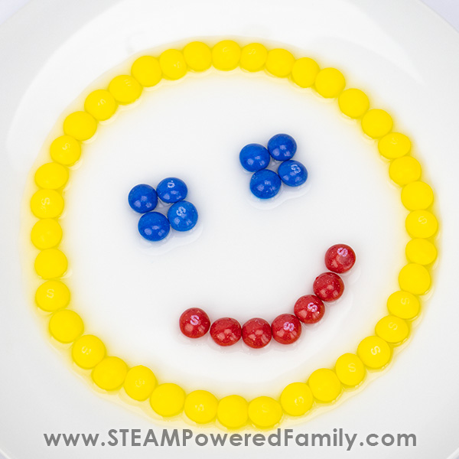  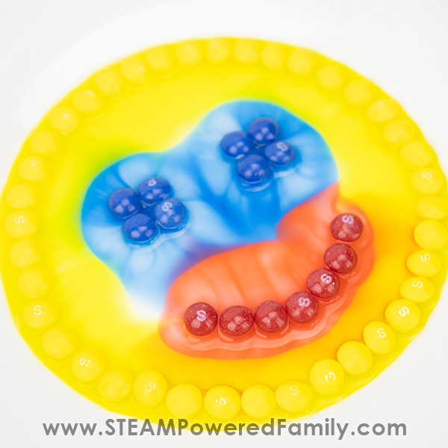 | Art  Follow this tutorial to draw Mickey Mouse in the style of Walt Disney himself  https://www.youtube.com/watch?v=R-JFC6cyTmc  Make a flip book of pictures which show a story  https://www.youtube.com/watch?v=Un-BdBSOGKY  PSHE  Worry Jar activity (in resources)  Ways to feel better activity (in resources)  Ways to feel better activity (see resource)  Music  Learn a song from a Disney film and perform it to your household.  Geography  Use a map to find the places Walt Disney lived.  Art  Design your own Walt Disney Cartoon Character.  Make a fireworks picture using paint and a toilet roll!  https://www.learning4kids.net/2015/12/27/painting-fireworks/  Try some of these fun Disney crafts  https://www.diyncrafts.com/38103/home/parenting/60-best-disney-crafts-for-kids-that-will-keep-them-busy-all-year-long  DT  Make an Oscar out of paly dough or junk or anything you have at home.  PSHE  You are AMAZING!  Create a poster to show how amazing you are. I am good at..  I am a great friend because…  I am proud of myself when…  I have worked hard to…  This link may give you some more ideas.  https://www.twinkl.co.uk/resource/i-am-an-amazing-person-t2-inc-4  Watch a Disney movie!
5 |  | Cartoon Strip  Create your own story for Mickey Mouse or one of Disney’s other characters and create a cartoon stip. Use the features of a comic strip ppt (in resources) to help you. | Comprehension  Alice’s adventures in wonderland inferences.  (DOES NOT need to be printed)  Read the extract and answer the given questions either on paper or verbally to an adult.  There are 3 levels of difficulty (* rating). Choose the right level of difficulty for you.  Link https://www.twinkl.co.uk/resource/t2-e-3075-alices-adventures-in-wonderland-inference-activity-sheet | Money - Buying a balloon  Lolla bought a balloon at the circus. She gave the clown six coins to pay for it.  What coins could Lolla have used to pay for the balloon?  Which of your answers seems a reasonable amount to pay for a balloon?  Measuring - Circus Cup Cakes  https://www.bbcgoodfood.com/recipes/cupcakes  Look at the recipe for cupcakes. These are sold at the circus but the recipe only makes 12. What if 24 people come to your circus? How much of each ingredient would you need then? What if you only need 18 cakes?  You could even have a go at making some circus cupcakes. | Fireworks in a glass  https://www.youtube.com/watch?v=JgNOuNh0Okg  Watch this clip for the instructions and the science behind the experiment.
Introduction |  | Using everything you have learnt you are going to design your own ‘Greatest show’
6 | Are you the greatest Showman on earth? | Persuasive poster  Design a poster on paper or the computer to persuade people to come and see your show. What will your show feature? Where will it be? Why will they not want to miss your act? How much are tickets? Any special offers? Think of a bold, catchy headline/slogan. | Comprehension  ‘The Roller Coaster’ (DOES NOT NEED TO BE PRINTED)  Read the text  1) Complete the grid: discuss with an adult or write down your answers.  2) Challenge: Complete Qs 2 – 4; either discuss with an adult or write the answers down.  LINK  https://www.twinkl.co.uk/resource/us2-e-153-the-roller-coaster-reading-activity-sheet | Money - Ticket Sales  Work out how much you are going to sell your tickets for, for your show. What will the price be for adults? What will the price be for children? Will you have any special offers? Will there be a family ticket?  Challenge: Explore combinations. How much would it cost for 1 adult and 3 children to watch your show? What is the difference between buying a family ticket and the cost for 1 adult and 1 child?  How much change would you get from different note values, e.g. £20, £50? | Floating Tower  Create a tower of different liquids and float different objects within the liquids to demonstrate density.  Fill a clear container with oil, honey and water and allow them to settle. Observe how the liquids settle. (The most dense liquid settles on the bottom and the least dense liquid settles on the top.)  What happens if you add drops of different food colours to the tower? What do you think will happen when a coin, a cork and a grape are dropped into the liquid tower? Place the items into the container and observe as each one floats in a different liquid. Each item has a different density, making them float in different materials. | PE & DT  https://theinspiredtreehouse.com/gross-motor-activities-flaming-hoops  Use hula hoops and fabric/tissue paper/construction paper, scarves to tie around your hoop and make a ring of fire! Follow the link above for further instructions and see the picture below. You could also make a hoop from foil, crushing the foil together then joining it form a loop.  Drama  Become a ring master! How will you introduce your show? Could you become a clown and perform any tricks? Think of different performers in the circus that you may choose to be in your show.  PSHE  Design a ring master hat of Positivity.  Helpful words and phrases: • You can do it! • Go for it! • Keep going! • I can do this! • This is great! • Challenge • Perseverance • Resilience • Determined • Goal • Reach for the stars! • Happy • Stick at it! • Super me!  DT  Use paper curls to make circus art. Follow the link to see how to draw an elephant or lion. You do not need to print the templates; you can draw them yourself.  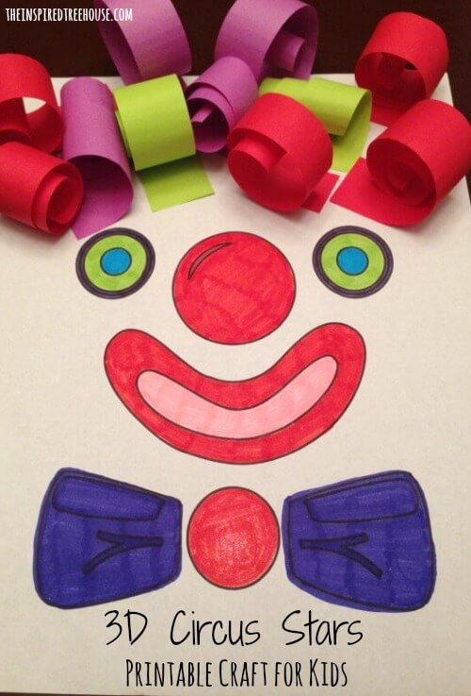  https://theinspiredtreehouse.com/printable-activities-for-kids-3d-circus-stars/
7 |  | Prepare and practise for your show. When you are ready, perform it to your family!!  Other ideas:  - Set up a food stall. Sell biscuits, popcorn, sweets, cakes and soft drinks (any food combinations possible!). Make a menu and price your items.  - Face painting. Any makeup left over from Halloween or everyday makeup you are allowed to use? Have a go at painting your face or someone in your family – if allowed!! Send us a photo. Alternatively, draw different face paint designs onto paper.  - Ticket stall – make your own tickets to sell.  - Costume – Go through the wardrobe and see what costume you can create!

